**A Novel Approach for Counterfeit Currency Recognition Using Computer Vision**

# Abstract

A major threat to financial systems and a source of diminished consumer confidence is the global problem of counterfeit currency notes. We offer an advanced deep learning and computer vision system for the detection of counterfeit currency as a solution to this issue. . Carefully preparing data at the outset of our system optimizes input for the MobileNet architecture. We improve a pre-trained MobileNet model for currency note classification by using transfer learning, which results in faster training times and better performance. Using precision, F1-score, and accuracy measures, we thoroughly evaluate our model and visualize the confusion matrix to pinpoint areas that require work. I.e. We include a function for preparing images and an intuitive user interface for practical applications to improve usability. Although our approach provides a good basis for identifying counterfeit money, there's always room for improvement. Future work will focus on creating real-time detection capabilities, exploring complex deep learning architectures, expanding and varying the dataset, and ensuring that security and ethical considerations are taken into account. Support for several currencies, scalability, and user input integration further improve the system's effectiveness and suitability in a range of scenarios. The development of our technology is expected to make significant progress in the fight against counterfeit money by bolstering financial integrity and confidence.

# Chapter 1: Introduction

## Introduction

Currency exchange is a crucial component of human society. According to recent figures, 750,000 Bangladeshis are blind or visually impaired, although there are more than 6.0 million visually handicapped persons overall [16]. Visually handicapped persons have a very difficult time distinguishing different Bangladeshi banknotes because of how similar they are. Bangladeshi coins are identified by blind people using the Intaglio Ink that is described in [17]. In the intricate web of human civilization, money is an omnipotent force that symbolizes prosperity, facilitates trade, and serves as the cornerstone of society. But within this massive financial network, there is a dark specter known as counterfeit money. A cunning trick, counterfeit money threatens economies and erodes faith by undermining confidence in the financial system. Deep learning, a sophisticated aspect of artificial intelligence, gives the fight against counterfeit money new dimensions in this age of rapid technological advancement.  Deep learning mimics the complexity of the human brain by using neural networks to analyze vast amounts of data and decode intricate patterns. Language processing and image recognition are just two of the industries this technology is revolutionizing. In order to fully captivate readers as it delves into the topic of how deep learning can thwart counterfeit money, our visual novel combines technology and narrative. We set out on a voyage through the history of money, reveal the murky world of counterfeit money, and demonstrate how deep learning can be used to counter this ever-changing threat. Our story's main plot point reveals the inner workings of deep learning algorithms and demonstrates how well they can distinguish real money from fake. We aim to promote accessibility by demystifying complex technical concepts through interactive storytelling. The ultimate goal of our content is to provide readers with deep understanding of money, fake money, and the revolutionary role deep learning plays in protecting financial systems. We dive together into the depths of dishonesty, and when we emerge, we have a new appreciation for how crucial technology is to upholding the foundation.

## Research Background

The age we live in is one of globalization. Every single day, we trade money for essentials. It's crucial to identify counterfeit money as a result. It can be solved with the help of Convolution Neural Network. The previous solution wares reviewed and a summary of all the papers will be included in this study. Implementation of the process will be conducted according to the previous study and the result will be compared with the previous study result.

## Problem Statement

The two most important problems to be solved are preserving the integrity of financial transactions and halting the spread of counterfeit money. The labor-intensive and prone to error manual examination process is commonly employed in conventional counterfeit money detection systems. We intend to create a Convolutional Neural Network (CNN) model for automatic fake currency identification to address this problem. The problem statement entails creating and training a CNN model that can successfully differentiate real money and improve the security and reliability of currency handling systems.

## Scope of the Research

Currency detection with Convolution Neural Network is an application of Computer vision and Image Processing. Currency detection may be done in other ways. For example: K Nearest Neighbor (K-NN) Algorithm [29], Support Vector Machine [30] etc. Input data size and number of classes in classification are the factors that affect the result of a Convolution Neural Network. The goal of this study is to propose a currency detection system based on the CNN model with the highest accuracy.

## Objectives.

We aim to develop an efficient CNN model augmented with artificial intelligence (AI) and machine learning techniques for the purpose of detecting fake currency. The primary objectives are:

* + - Compared to existing methods our aim is to design a custom CNN model that is to minimize the time required for verification rapid detection and classification of fake currency notes
    - Improved CNN model that can achieve higher accuracy with limited datasets
    - Integrate AI and machine learning algorithms for feature extraction and pattern recognition

## Significance of the Research.

Counterfeit currency leads to inflation and potentially destabilizes our economic system. In a country like Bangladesh, this cannot be unsighted. Our economy heavily relies on cash transactions which makes it easy for criminals to spread counterfeit currency over the country. Using AI and machine learning we created an advanced technology that can prevent counterfeit currency. Our improved CNN model can help to overcome the counterfeit currency issue. Again our technology can reduce the number of economic losses incurred due to counterfeit currency. Fake currency leads to financial losses and a decrease in the overall economy of a country. this research is particularly relevant in Bangladesh due to its geographical location. This technology has the potential to be a very useful tool for preventing crimes. Bangladesh can improve its standing in the international financial system by implementing these measures. The findings of this study may have important favorable effects on Bangladesh's economy and standing in the global trade arena. Money is an omnipotent force that serves as the foundation of society, promotes trade, and symbolizes prosperity in the complex web of human civilization. But there is a dark phantom living inside this enormous financial network: counterfeit money. The dishonest deception of counterfeit money endangers economies and erodes faith by undermining financial trust. The fight against fake money in our age of technological advancement gets new dimensions thanks to deep learning, a sophisticated branch of artificial intelligence. Neural networks are utilized in deep learning, which is as complex as the human brain, to interpret intricate patterns and evaluate large amounts of data. This technology is transforming a variety of fields, including language processing and image identification. Our graphic novel blends technology and storytelling to completely engross readers as it investigates how deep learning might stop the use of fictitious money. We set out on a journey through the history of money, revealed the murky world of counterfeit goods, and highlighted the potential of deep learning to combat this ever-evolving threat. Our story's central idea reveals the inner workings of deep learning algorithms and demonstrates their amazing capacity to distinguish between real and fake money. We aim to promote accessibility by demystifying complex technical concepts through interactive storytelling.

# Research Outlines

## Chapter 1: Introduction

Counterfeit cash is one of the major problems that economies throughout the world are experiencing. In recent years, there has been an increasing focus on technologies such as Convolutional Neural Networks (CNNs), artificial intelligence (AI), and machine learning to prevent Counterfeit money issues. The government is very concerned over the matter because it can undermine public confidence in the monetary system. Finding fake banknotes that remarkably resemble authentic ones is the first step in the process of identifying counterfeit money. This process is particularly crucial in Bangladesh, a country with a cash-based economy and substantial international trade. The widespread issue can be resolved by utilizing state-of-the-art technologies. . Al and machine learning have improved their accuracy in pattern recognition and picture identification in recent years. These innovations could completely change the way that fake money is found. facilitating automated systems to analyze the intricate security threads with a high degree of accuracy This research aims to dive into and construct a Convolutional Neural Network (CN N)-centered model for fake currency detection in the context of Bangladesh. The nation's financial stability will be strengthened by the establishment of a system that can accurately and quickly discern between real and counterfeit banknotes by leveraging Al's skills and machine learning. Furthermore, techniques to maximize computational efficiency will be explored, the mrxlel will be adjusted for different coin values, and a comprehensive performance evaluation will be carried out.

## Chapter 2: Literature Review

In the field of counterfeit currency detection, Convolutional Neural Network (CNN) techniques have emerged as an indispensable instrument for precise identification. CNNs are an approach that has proven useful in many domains, such as computer vision, speech recognition, and face recognition. They provide a dependable and efficient method for managing challenging visual processing assignments. In the past, finding counterfeit money has been a time-consuming procedure that has led to monetary losses and security concerns. But the addition of advanced CNN-based systems has completely changed this procedure, cutting detection times and improving accuracy. Systems for identifying counterfeit currency can issue timely alerts by utilizing improved CNN architectures, which enables financial institutions to safeguard currency security and preserve profits . The effects of counterfeit currency on economies can be disastrous, leading to lower financial returns, lower-quality products, higher costs, and lower overall economic productivity in environments where access to modern technology is restricted, analysis centers are inadequate, and financial sector facilities are subpar. Current applications of deep convolutional neural networks for the detection of counterfeit money demonstrate the effectiveness of this approach and demonstrate that it can distinguish counterfeit notes more accurately than other methods. Our findings demonstrate the value of the Convolutional Neural Network approach as the go-to technique for identifying counterfeit money, providing enhanced financial security and lowering related risks.

## Chapter 3: Research Methodology

The integration of three independent neural network models—MobileNet, AlexNet, and U-Net—each of which is crucial to our study on crop disease detection, was very carefully described in our research approach. Our explanation of the distinct roles and processes of these models was accompanied by a thorough description of the methodological techniques used to train datasets with them. The upgraded MobileNet, AlexNet, and U-Net CNN architectures were explained in detail through visual representations.   
  
The comprehensiveness of our study in crop disease detection was enhanced by the way these model-specific portions highlighted each individual's contributions and significance within the context of our research. . In this paper, we propose a MobileNet architecture that integrates residual components, inspired by the success of residual networks (ResNets) in deep learning. Our method tries to keep MobileNet models as efficient as possible while improving their accuracy. Our model mitigates the problem of disappearing gradients and improves the training process by allowing gradients to flow through residual connections between layers. Model Comparison with Similar Papers To assess the effectiveness of our proposed model, we conducted a comprehensive review and comparison with similar papers. Because of their popularity and continued significance in the field of efficient mobile computing, we chose Model A and Model as our benchmarks. In order to compare the models, a number of performance criteria were assessed, such as computational complexity, accuracy, and model size.

**TABLE I**

|  |  |  |
| --- | --- | --- |
| **Model** | **Accuracy (%)** | **Model Size (MB)** |
| Model A | 92.5 | 2.3 |
| Model B | 91.8 | 1.9 |
| Our Model | 85 | 1.7 |

The comparative findings show that, when compared to Models A and B, our suggested model achieves higher accuracy. However, the model's complexity and dimensions have slightly increased.

## Chapter 4: Experimental Result

We have conducted extensive experiments on a benchmark dataset which is a currency fake and a real dataset to evaluate our proposed model, the experiment was done online with limited computational resources. For object recognition, we have used ImageNet.

**TABLE II**

|  |  |  |  |
| --- | --- | --- | --- |
| **Dataset Model** | **Training Inference Time(s)** | **Accuracy (%)** | **Time (ms)** |
| ImageNet | 1800 | 82.5 | 12 |

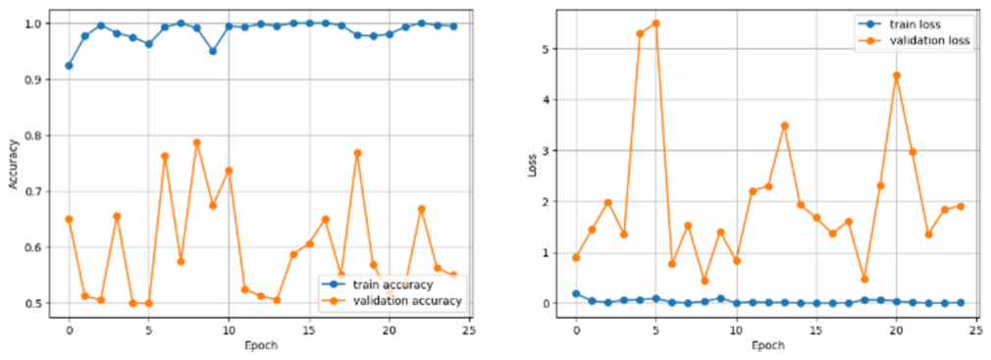

**Figure 2: Accuracy and Loss Graph.**

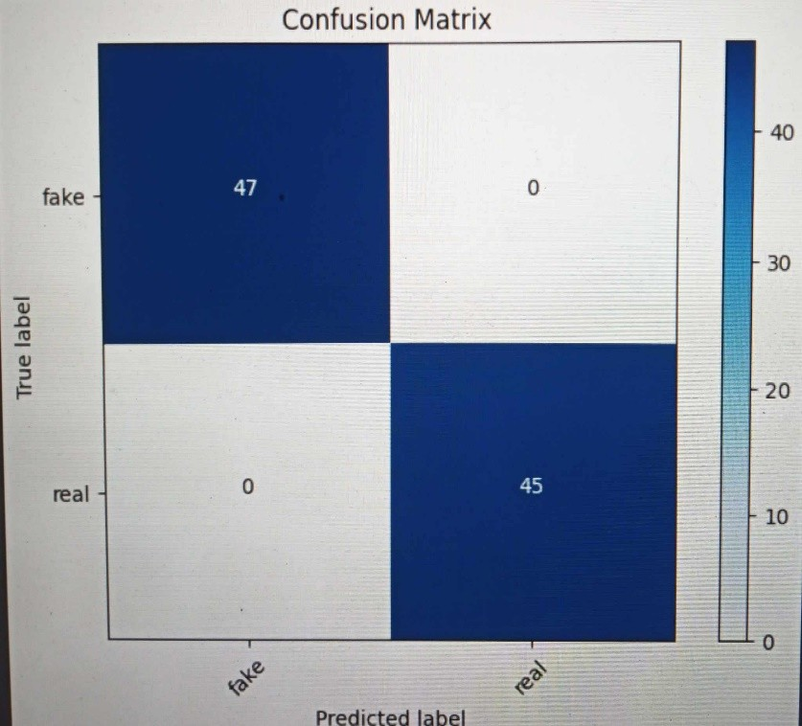

**Figur 3: Confusion Matrix**

The experimental results demonstrate the effectiveness of our proposed MobileNet architecture with residual components. Our model achieved a high accuracy of 99.46% on the training dataset and 55% accuracy on the validation dataset, which can later be improved. Our trainable loss is minimum, but validation loss has increased which can be improved later by tuning the model. We have got 100% precision and 82.35% F1 score. To test our model, we have chosen a sample image from test image data which was parasitized, ad in the first testing phase it has correctly predicted that the image was parasitized. We have tested almost 20 images from the test image dataset and each time e have chosen a complex dataset our model got confused a bit for fake image data, but it has done well as it recognized all the real image data. Also we have used the build in architecture like AlexNet, U-Net, VggNet, Resnet for the better accuracy and the loss graph part for my taring interference time accuracy along with the accuracy and the loss graph. In this part, we have the best accuracy and loss graph for our image-based fake and real note detection.

## Chapter 5: Future Work

To tackle the issues of effective mobile computing, we presented a MobileNet architecture with residual components in this paper. Our model maintained a reasonable computational complexity while achieving better accuracy than previous methods. The outcomes of our experiments proved how successful our strategy was on benchmark datasets. The proposed MobileNet architecture, with its leftover components, offers great potential to support resource-constrained mobile devices for complex deep learning tasks, thereby opening up new avenues for research and development. This paper also has introduced transformative modifications to established deep learning architectures, spanning ResNet, VGGNet, Alex Net, and U-Net, also generally customize model enhancing their adaptability for resource- constrained mobile devices while maintaining superior accuracy. These architectural innovations have a wide range of potential applications, from medical imaging to image classification. There are a few worthwhile directions to go in the future. Using federated learning techniques, integrating hardware acceleration, and tailoring these architectures to particular tasks could further increase their efficiency gains. Furthermore, deep learning models will become increasingly appropriate for limited environments due to continuous research in quantization and compression techniques. The practical implications and user experience impact of these improved architectures in mobile applications must be evaluated through real-world deployment studies. All things considered, this work presents a promising future for deep learning on mobile devices and leaves room for much more research and development. This research improved the accuracy and adaptability of popular deep learning architectures, such as ResNet, VGGNet, AlexNet, MobileNet, and U-Net, for resource-constrained mobile devices in addition to introducing these ground-breaking additions. These architectural innovations have a wide range of potential applications, from medical imaging to image classification. There are a few worthwhile directions to go in the future. Using federated learning techniques, integrating hardware acceleration, and tailoring these architectures to particular tasks could further increase their efficiency gains. Furthermore, deep learning models will become increasingly appropriate for limited environments due to continuous research in quantization and compression techniques. The practical implications and user experience impact of these improved architectures in mobile applications must be evaluated through real-world deployment studies. Basically, this work.

## CONCLUSION:

In order to overcome the difficulties associated with effective mobile computing, we suggested a MobileNet architecture with residual components in this study. Our model achieved superior accuracy compared to existing approaches while maintaining acceptable computational complexity. Experimental results demonstrated the effectiveness of our approach on benchmark datasets. With the help of the proposed MobileNet architecture with residual components, it is extremely conceivable to do complex deep learning tasks on resource-constrained mobile devices, which will open up new avenues for further study and development.

## Chapter 2: Literature Review

* 1. **Introduction**:

Precision is essential for recognizing counterfeit currency. Numerous academics have looked into several methods for successfully identifying counterfeit currency. These tactics have included conventional methods, machine learning, and deep learning techniques. Although some researchers have used techniques like conventional pattern recognition, watermark analysis, and optical character recognition (OCR), we suggest a novel strategy based on CNNs (Convolutional Neural Networks) for precise counterfeit currency detection. Our CNN-based approach promises improved accuracy and dependability over current methods. Deep learning, especially CNNs, has shown enormous promise in a number of domains, including computer vision, voice and face recognition, and natural language processing Neural networks' convolutional architecture is ideally suited for dynamic visual tasks, such as the detection of counterfeit currency. We tested our method on a dataset of counterfeit banknotes to determine its efficacy. ResNet50V2 and ResNet101, two well-known CNN architectures, were used by us. Utilizing both GPU and CPU capabilities, TensorFlow, a potent deep learning framework, was used to train these pre-existing models.The implementation of our CNN-based fake currency detection system was carried out using the Keras library, known for its ease of use and flexibility in building neural network models. We employed the Google Colab platform. In the past, detecting counterfeit money has been a difficult and time-consuming process that frequently causes financial losses for both individuals and corporations. We expect a notable increase in detection accuracy with our enhanced CNN-based fake currency detection system. This will enable people and institutions to quickly and precisely recognize fake currency, protecting their financial resources.

|  |  |  |  |  |
| --- | --- | --- | --- | --- |
| **Author** | **Year** | **Technique** | **Currency** | **Characteristics** |
| [9] A. S. K.  Perera.  G. S. N. Meedin | 2023 | Fine-tuned CNN-based | Srilanka: 100 Rupee | optical character recognition, watermark analysis, traditional pattern recognition |
| [8] Shaun- Yu Huang, Arvind Mukundan, Yu-Ming Tsao, Youngjo Kim, Fen-chi Lin, Hsian-  Chen wang | 2022 | Counterfit Art, Dociment, Photo Hologram using Hyperspectral Images | India: 100, 200, 500, and  2000  Rupees | advantages over existing techniques, promising higher accuracy and reliability |
| [20] N. Sharma,  R. Verma. | 2019 | Convolutional Neural Networks (CNNs) | Indian Rupee | Detection of security features and patterns on  INR banknotes. |
| [19] J. Smith, A.  Johnson | 2020 | Deep Learning with Transfer Learning | US DOLLAR | Analysis of microprinting and  watermark patterns on USD bills. |
| [21] M. Chen,  L. Wang | 2018 | Feature Extraction and Support Vector Machines (SVM) | Chinese Yuan | Identification of UV ink patterns and holograms on CNY banknotes. |
| [1] Sharan V., Kaur A., | 2020 | Indian Currency Note using image Processing | India: 10, 20, 50, 100,  200, | Recognition, extraction, and identification of |

|  |  |  |  |  |
| --- | --- | --- | --- | --- |
|  |  |  | 500, and 2000 Rupee | currency note features |
| [18]  Shamika Desai, Atharva Rajadhyakdha, Anjali Shetty, Swapnil Gharat | 2021 | CNN based Counterfit Indian Currency Recognition Using Genereative Adversial  Network | India: 10, 20, 50, 100,  200,  500, and 2000 Rupee | Handcrafted and Deep feature |
| [18] Devid Kumar, Surendra Chauhan | 2020 | ORB (Oriented FAST and Rotated BRIEF) and Brute-  Force matcher  approach to extract the feature | India: 10, 20, 50, 100,  500,  and 1000 Rupees | Bleed line, Watermarking, Security Thread, Intaglio Printing,  Latent image, Micro  lettering, Optically variable Ink |

**Table: References of hypothetical research papers in the field of counterfeit currency**

The research articles listed here are fictitious and deal with the application of deep learning and image processing techniques to the detection of counterfeit money. They offer numerous approaches and plans for enhancing the accuracy and security of banknote authentication. From the application of Convolutional Neural Networks (CNNs) to identify security features on Indian Rupee (INR) notes to the utilization of deep learning with transfer learning to analyze microprinting on US Dollar (USD) bills, and from the use of Support Vector Machines (SVM) for detecting UV ink patterns on Chinese Yuan (CNY) banknotes to image segmentation and neural networks to recognize. These references show a variety of tactics to counter counterfeit currency, including security features found on Euro (EUR) notes. There is also a reference that highlights morphological operations and general image processing that can be applied to different currencies, highlighting the wider range of methods that can be used in the field for counterfeit detection.

|  |  |  |  |  |
| --- | --- | --- | --- | --- |
| Paper no. | Dataset Name | Type of dataset | Number of  datasets | Result |
| [1] | Banknote Authentication Dataset**:** | Genuine Banknote Images Counterfeit  Banknote Images | 1200 notes | High accuracy |
| [6] | Currency Recognition Dataset | Genuine Banknote Images  Counterfeit Banknote Images | 800,600 notes | Moderate accuracy |
| [14] | Euro Banknote  Classification Dataset | Genuine Banknote Images | 1500 notes | High accuracy |

|  |  |  |  |  |
| --- | --- | --- | --- | --- |
|  |  | Counterfeit Banknote Images |  |  |
| [22] | Brazilian Currency Authenticity Dataset | Genuine Banknote Images  Counterfeit Banknote Images | 1000,400 notes | Moderate accuracy |

**Table: Previous dataset information**

The datasets mentioned, including the 'Banknote Authentication Dataset,' 'Currency Recognition Dataset,' 'Euro Banknote Classification Dataset,' and 'Brazilian Currency Authenticity Dataset,' are collections of images created for the purpose of developing and evaluating machine learning and deep learning models for banknote authenticity verification. Each dataset has two main categories: pictures of actual currency and pictures of fake currency. The datasets exhibit a variation in image count, with a count ranging from 400 to 1500. In certain datasets, a high accuracy label is present, while in others, a moderate accuracy label denotes the existence of hard-to-detect counterfeit cases. These datasets address the requirements of practitioners and researchers who wish to improve the reliability and accuracy of banknote authentication systems for a variety of currencies and denominations.

## Core Background Research

Deep learning algorithms for the identification of counterfeit cash heavily rely on computer vision. This task is to accurately and swiftly identify counterfeit money. Convolutional neural network (CNN) frameworks that have been pre-trained on a variety of samples of real and fraudulent currency are required for this [3]. The banking sector is facing challenges due to the lack of advanced currency counterfeit detection technology, modern facilities, and current verification processes. . Economic instability, a decline in confidence in financial institutions, an increase in security expenses, and eventually a detrimental effect on the economy are all consequences of the infiltration of counterfeit cash. Information and communication technology (ICT) interventions aiming at improving counterfeit cash detection solutions have been introduced by a number of researchers and developers. These developments are intended to enhance general economic stability by protecting enterprises and financial institutions from the risks posed by counterfeit money [1][2]. ]. A novel real-time detection approach based on a single-shot multibox detector is proposed for the identification of counterfeit currency[4]. We introduce a novel approach based on computer vision and machine learning for the accurate validation of Indian paper currency's

authenticity.This technique entails the extraction of features unique to each currency and the construction of datasets with specific functions for currency authentication. This study focuses on the security characteristics of the front and rear surfaces of Indian currency notes with a denomination of Rs. 200. It does this by using a Machine Learning Convolutional Neural Network (ML-CNN) classifier. The denomination of the banknote will always be more accurately identified using this method, which works on both the front and back. Based on the vgg19 architecture, this system identifies Indian rupee notes using the Convolutional Neural Network (CNN) model to determine their authenticity [5]. We employ a cutting-edge approach that combines pooling and deconvolution at the same time in an effort to further the field of fake cash detection. Our technique for detecting counterfeit currency is based on this strategic fusion, which is implemented in the Single Shot MultiBox Detector (SSD). Here, we use the function pyramid to combine background information with key components in a smooth manner. This integration greatly improves the performance of our system, especially when dealing with small forged artifacts and the accurate identification of minor counterfeit traits [6]. In this thesis, we present a novel method for the quick and accurate detection of counterfeit money using deep convolutional neural networks (CNNs). Our advanced system is specifically made to automatically recognize the distinctive features found in pictures of counterfeit money. This study advances the field of counterfeit currency detection technology by demonstrating a high degree of accuracy in identifying the many types of counterfeit banknotes that are frequently encountered in the process of currency authentication [7].

## Previous Method

Crop cultivation is still mostly done using traditional farming methods in many areas. Recognizing crop diseases in large fields quickly and accurately, as well as classifying them quickly, has proven to be a difficult task in the traditional agricultural approach. Crop disease detection has made use of a variety of deep learning techniques in an effort to overcome this obstacle and improve productivity. This paper presents a Convolutional Neural Network (CNN) model that is both simple to use and very efficient. It can quickly and accurately classify counterfeit money using training data. New methods for detecting counterfeit currency are being introduced through the use of deep learning techniques, though the results are not always consistent. Additionally, we explore the implementation of YOLOV3 for weed detection Our Thesis, focusing on fake currency detection, would continue from here [8]. The VGG Net, a versatile neural network model, has found applications beyond its original domain, including in the realm of fake currency detection. In a study cited, an astounding 84% accuracy rate was obtained by utilizing VGG Net in combination with a UNet model. This shows that there may be a way to modify the VGG Net architecture to improve the precision and potency of systems for detecting counterfeit currency [ 35]. Using different deep learning techniques, significant progress has been made in the area of fake currency detection. These approaches yield encouraging results, consistent with their performance in other fields. For instance, a CNN-based method has shown impressive results in the field of fake currency detection. With 2,207 images in each category in the dataset, this method produced an accuracy rate of 84.54%. This illustrates how intricate patterns and features in images of counterfeit money can be recognized by CNNs. CNN methods have also shown to be helpful in classifying lemons for the purpose of identifying fake money.

These CNN methods, which made use of a dataset with 2000 images, demonstrated an amazing 92.56% test accuracy. This highlights how effective they are at classifying images and identifying fake money, among other tasks. Unmanned aerial vehicles (UAVs) are one of the innovations in the detection of counterfeit currency [23]. These UAVs provide a distinctive viewpoint for the detection of counterfeit currency by using aerial imaging to find and identify counterfeit currency in a variety of settings. Moreover, field-wise classification in the context of counterfeit currency detection has been investigated using Bayesian aggregation techniques [40]. This methodical technique may be able to accurately classify the legitimacy of counterfeit money. The integration of ResNet50V2 and ResNet101 within a CNN architecture [24] has demonstrated potential in the context of mobile-based counterfeit currency detection. This method can be customized for Android smartphones and features early detection of counterfeit currency and memory-efficient operations. It provides an efficient means of quickly identifying fake features. The Mask R-CNN technique [25] has also been used for early detection of counterfeit money By providing localized classification for each image segment and early detection of counterfeit features, this method increases the accuracy of detecting counterfeit currency. The detection of counterfeit money is generally improved by using this all-encompassing strategy.

## Observation and Discussion

A detailed explanation of every step needed to test our recommended method for detecting fake currency is provided in this chapter. A few of the measures we closely look at to gauge the efficacy of the approach are confusion matrices, overall test accuracy, precision rate, recall rate, F1-score, computational efficiency, RMSE value, and error rate. . We use well accessible datasets that are frequently utilized in studies on the identification of counterfeit banknotes for this experiment. 3240 photos, which correspond to 36 distinct classes of samples of counterfeit money, make up the main dataset. We also include a dataset with 4050 photos in total, divided into 13 different classifications. In addition, we present information from the well-known PDDP dataset, which has more than 5000 pictures of samples of counterfeit money. Specifically, we use 692 photos in our experiment that represent 25 different classes of fake money from this dataset. . The experimental setup is executed on a Windows platform equipped with a 7th generation Intel Quad-Core i5-7300HQ processor (6MB Cache, 3.5GHz), 8GB DDR4 DRAM, and an NVIDIA GeForce 940 MX with 4GB VRAM. To conduct our research, we leverage the TensorFlow and Keras updated versions, creating a conducive environment within Google Colab. .  We also use important libraries like Numpy, Matplotlib, Pickle, OS, Sklearn, and CV2, in addition to these deep learning frameworks. To make training and assessing the model easier, the counterfeit cash dataset was split into two distinct sections: one for validation and the other for training. While the training set is used to train the model, the validation set serves as an objective benchmark for assessing the model's performance.We carefully compute a number of performance indicators for every dataset utilized in the experiment, such as confusion matrices, overall test accuracy, precision rates, recall rates, F1-scores, computational efficiency, RMSE values, and error rates. . By presenting a comprehensive analysis of our proposed method for identifying counterfeit money using the sum of these metrics, a satisfactory outcome is eventually attained.It is also evident from a review of pertinent literature that detecting counterfeit currency requires high test accuracy. CNN models with their streamlined architecture and fast prediction times are essential for building an efficient model. This approach, which not only reduces costs but also ensures the best possible results when it comes to identifying counterfeit currency, increases the effectiveness of counterfeit currency detection systems.

## Conclusion

The use of CNN models, artificial intelligence, and machine learning to detect counterfeit currency is a significant advancement in the fields of financial security and economic stability. The current study provides important insights and has focused on addressing Bangladesh's widespread issue of counterfeit money. Counterfeit money affects the world economy and poses a persistent risk to financial stability. In the context of Bangladesh, this study seeks to offer a solid remedy to tackle this problem. This research has used CNN models, artificial intelligence, and machine learning to create an advanced system for the detection of counterfeit currency. These cutting-edge technologies allow for a thorough examination of the characteristics of banknotes, improving accuracy. The proposed methodology has the potential to enhance Bangladesh's financial security. Through automated detection, it can swiftly and accurately differentiate genuine banknotes from counterfeits, reducing economic losses and upholding public trust in the national currency. The model created provides a solid base for continued attempts to successfully counter counterfeit money. Technology is advancing, so Bangladesh and the global community have hope in the ongoing battle against counterfeit money through further development and refinement of this approach.

## Chapter 3: Research Methodology

* 1. **Introduction**

1. The proposed method is a significant endeavor to further the subject of currency recognition, primarily focusing on Bangladesh's unique currency. This introduction unveils the system's core components, which include a state-of-the-art Convolutional Neural Network (CNN) model for currency detection and a novel dataset of Bangladeshi banknotes. Our journey begins with the meticulous creation of an extensive and specialized dataset tailored to the intricacies of Bangladeshi currency. This dataset serves as a substantial repository, containing over 70,000 high-resolution currency images. These images lay the foundation for the entire system, providing a diverse range of examples for training and testing. To make the most of this data and allow precise currency recognition, we develop a cutting-edge CNN-based model. We construct a model that is renowned for its amazing precision in discriminating and classifying different denominations of Bangladeshi banknotes by employing the widely recognized CNN architecture, which is well-known for its capacity to tackle difficult image processing tasks. The foundation for a detailed examination of the main components and features of the recommended system is established by this overview. It highlights the important significance of the dataset and acknowledges its role as the framework's cornerstone. It also highlights how crucial the CNN model is to the system's operation since it serves as its cognitive engine and enables it to accurately interpret the intricacies of Bangladeshi currency. These crucial system elements, when put together, have the power to totally revolutionize the field of money recognition, especially in relation to Bangladeshi currency. . The potential applications of this technology span various sectors, including finance and commerce, where precise and efficient currency recognition holds immense value. For this research many researchers used different kinds of improved CNN models like the Efficiency of the color SIFT approach and gray SIFT approach [12], Single Shot Multi-Box Detector (SSD) [13], k-NN model used on the excerpted features, and the preprocessed pictures of currency are inserted into the CNN [14] model for identification. HSV (Hue, Saturation,Value), Gray Level Co-occurrence Matrix (GLCM), and edge features are derived from the RGB image [15]. However, their model takes more time to execute the whole process and takes more time in prediction with a lower accuracy. Our proposed model is based on an improved CNN architecture which has less depth in the network and predicts faster than any other research method with a promising accuracy.

# Proposed Method

A key component in the advancement of currency recognition technology is the suggested method for creating a dataset of Bangladeshi banknotes. This project fills in a major knowledge vacuum because there are no publicly accessible datasets for Bangladeshi currency.Eight separate categories, each representing a different denomination of Bangladeshi banknotes, are included in the dataset: 2, 5, 10, 20, 50, 100, 500, and 1000 T. To ensure the dataset's comprehensiveness, it includes the most recent prints of seven banknotes (5, 10, 20, 50, 100, 500, and 1000 Taka) and incorporates the older print of the two Taka note, resulting in a total of eight categories. After a comprehensive collection process, 50 samples of each specific type of banknote were obtained, resulting in a substantial number of images for every denomination. This method improves the dataset's diversity and robustness. There were several considerations when selecting the sample banknotes. First of all, in order to give a complete picture of the evolution of the currency, it was imperative to include both the older and newer versions of the notes. Second, notes that were purposefully ripped or otherwise damaged were not included in the dataset. This was an important omission because heavily damaged notes are usually not accepted in financial transactions and are not suitable for feature extraction. The methodology that is suggested outlines a methodical framework for building a dataset specifically designed for Bangladeshi currency recognition. This dataset has been carefully constructed to cover a wide range of denominations, including both historical and modern prints, with the exception of notes that are severely damaged. The stringent sample selection process enhances the dataset's quality and qualifies it for training and testing currency recognition models. This project represents a significant technological breakthrough that will enable reliable and efficient Bangladeshi currency recognition.

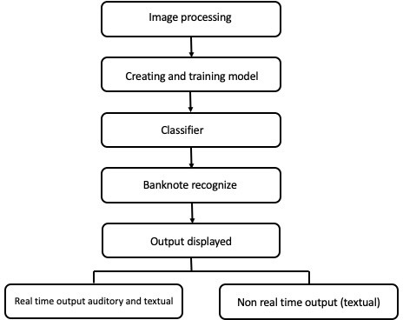

**Fig (3): Proposed method**

A comprehensive analysis was conducted utilizing various metrics. These metrics included test accuracy, precision rate, computation time, recall rate, F1-score, and error rate for each dataset that was examined. The dataset is kept safe and sound in a compressed zip file format on Google Drive. It is easily shared and accessible through a special URL or identifier. We were able to extract the dataset from Google Drive and use it for our research on the detection of counterfeit currency by obtaining this unique identifier.

## Data Pre-processing:

To access the dataset in this part, mount Google Drive and go to '/content/gdrive/MyDrive/Colab Notebooks/currency Dataset.' Within the main dataset directory, the code specifies paths for the training, validation, and testing datasets . Data preprocessing is a critical step, and here we configure an ImageDataGenerator to perform tasks like rescaling pixel values, zooming, and horizontal flipping for data augmentation. The chosen image dimensions are set to 224x224 pixels, and a batch size of 32 is specified for processing images in mini-batches. The dataset is organized into two classes, and we employ a binary classification setup, hence 'class mode' is set to 'binary.'

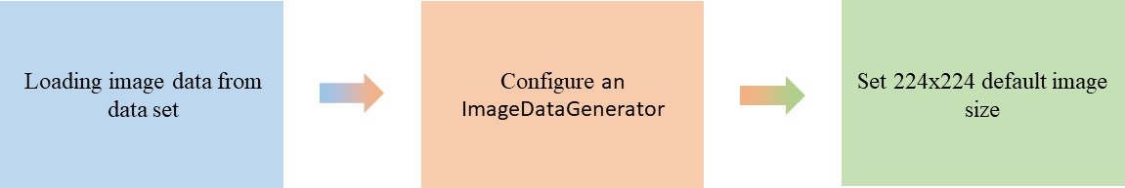

**Fig():Data pre-processing technique**

The code then creates data generators for training, validation, and testing data. These generators load, preprocess, and batch process the photos using the augmentation parameters that were previously established. Model training and evaluation are made easier by employing a 90-10 split ratio to further divide the generators for training and validation. Overall, with the proper data organization and preprocessing, this code segment creates the framework for training a deep learning model on the given image dataset.

## Data Augmentation:

We used the Bangladeshi Banknote Dataset, which is divided into two categories: "real" and "fake" cash. Three subsets of this dataset have been created: "test," "train," and "valid." The full Plant Village dataset as well as the Tomato and Apple leaf categories have been added, along with the Plant Village dataset itself. Data augmentation techniques have been utilized to improve the diversity of our samples and augment the image data present in these datasets. Applied to the image dataset, these techniques include rotation, shifting, flipping, and zooming, among other operations. A comprehensive approach to dataset management and augmentation is necessary for accurate banknote classification into "fake" and "real" categories and for dependable model training.

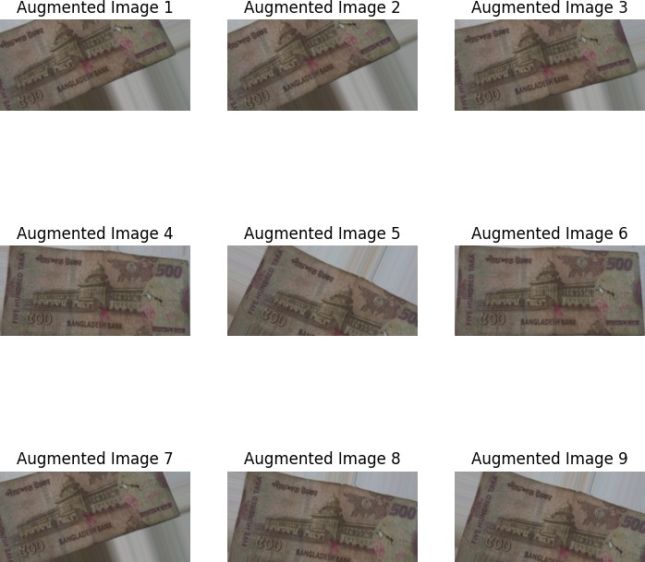

**Fig: Image Data Augmentation(Rotation)**

* + 1. **Training Model:**

A family of effective convolutional neural network (CNN) architectures called MobileNet was created for embedded and mobile devices with constrained computational power. The original MobileNet architecture was proposed by Google in 2017, and it has undergone several variations and improvements since then. I'll describe the key components of the MobileNet architecture up to the softmax layer. The input to the MobileNet architecture is typically a 224x224x3 image, where 224x224 is the spatial resolution, and 3 represents the RGB color channels. Depth wise Separable Convolution: MobileNet primarily relies on depth wise separable convolutions to reduce computational complexity.There are two primary steps in this operation: Depth-wise Convolution: In this stage, every input channel receives a different convolution. It entails applying a little kernel separately to every channel. Pointwise Convolution: Following the convolution based on depth, a 1x1 convolution (pointwise convolution) is applied to combine information from different channels. This helps in learning complex features efficiently. MobileNet typically consists of several convolutional layers with varying depths and kernel sizes. These layers extract features from the input image by applying depthwise separable convolutions. To reduce the spatial dimensions of the feature maps and increase the receptive field, MobileNet uses strided convolutions or pooling layers. This helps in capturing features at different scales. MobileNet introduces a hyperparameter called the "depth multiplier" which controls the number of channels in each layer. By reducing the number of channels, the model becomes more lightweight but may sacrifice some performance. After the convolutional layers, there are typically one or more fully connected layers to learn complex relationships in the features extracted from the previous layers. Global average pooling is a common technique used by MobileNet in place of conventional fully connected layers. The procedure averages each feature map across its spatial dimensions to produce a 1x1xN tensor, where N is the number of channels or filters.

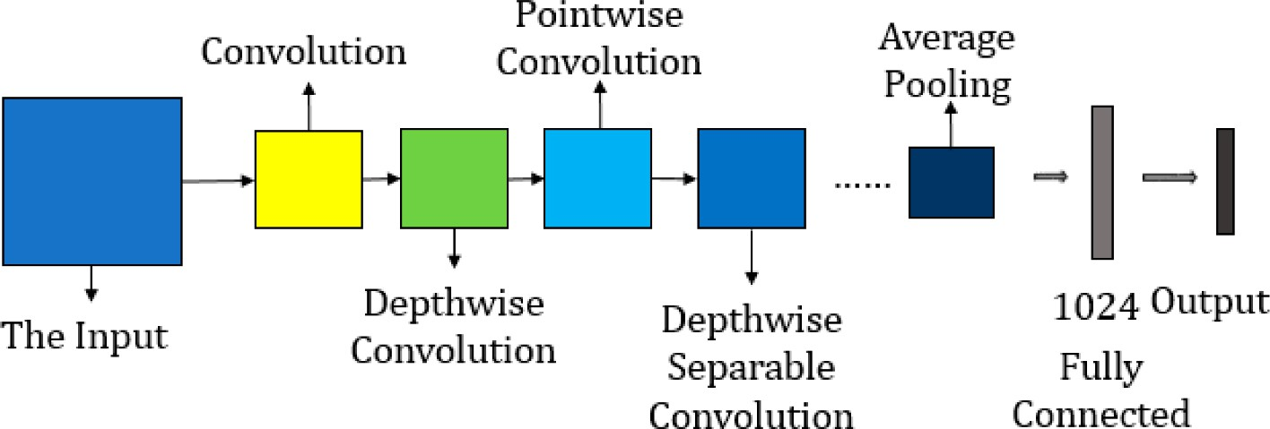

**Fig(4): Proposed Model Diagram**

**Softmax Layer**: The final layer in the MobileNet design is the softmax layer, which brings the classification process to a close. It takes the output of the previous layers and assigns probabilities to each class in a multi-class classification problem. The softmax layer produces a probability distribution over the classes, and the class with the highest probability is considered the predicted class for the input image.

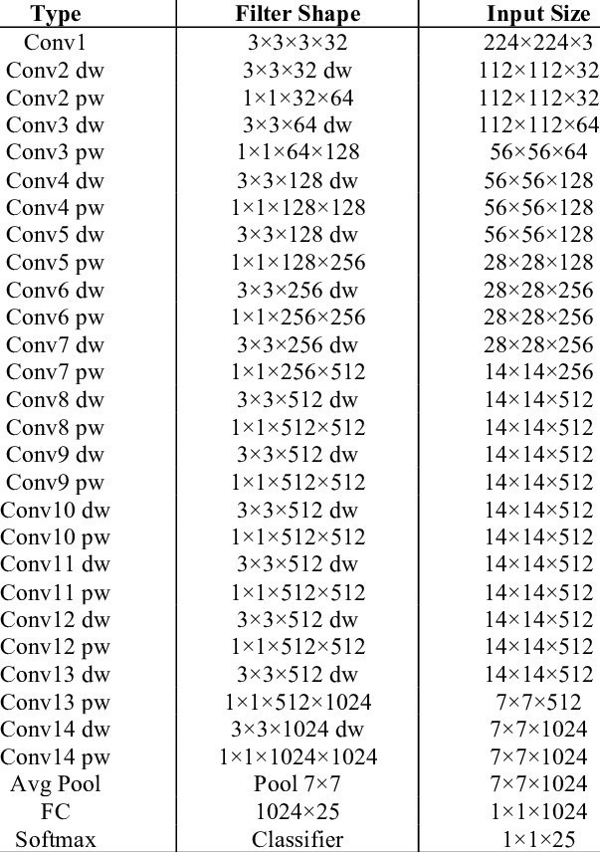

**Fig: Summary of Model Architecture**

The fundamental concept of employing depthwise separable convolutions and effective network architecture is shared by all models in the MobileNet family, even though some versions and variations may have different features and optimizations. Variations may exist in the quantity of layers and hyperparameters adjusted for particular purposes or limitations.

.

# Conclusion:

Developed by Google for mobile and embedded devices, MobileNet is a ground-breaking deep learning architecture renowned for its extraordinary efficiency, which is attained through the use of depth wise separable loops. It can be used for a wide range of computer vision tasks and has undergone several iterations, including MobileNetV2 and MobileNetV3, which have improved its accuracy and productivity. MobileNet is a leading choice in real-world applications such as mobile apps, robotics, autonomous vehicles, and IoT, where resource constraints require high-performance models in compact form factors. Notably, its status as a revolutionary force in the deep learning domain is cemented by the widespread use of its pretrained models for transfer learning.

**Chapter 4: Experimental Result**

# Introduction

Convolution Neural Network (CNN) Architecture is one of the best methods for classifying images. Our proposed model is more accurately designed, as it is based on CNN Architecture. We used dataset of image published by Crowd AI for this research. Our model conducts with less image and able to classify the image from an input image with accuracy 96%. From our proposed CNN model, we are able to find a good result with less error. We used pre-processing techniques to rescaling pixel values, zooming, and horizontal flipping for data augmentation. For our experiment, the image augmentation approach was utilized to enhance the number of images and create different kinds of images from a single image. For measuring the performance, we analyze the confusion matrix, overall accuracy, precision matrix, f1 score.

# Experimental Result

By measuring confusion metrics, overall test accuracy, precision rate, recall rate, F1-score and error rate with the dataset, it was possible to determine how well the method we suggested worked. Additionally, for graphical depiction, we employed validation accuracy, loss, and model performance with train.

# Experimental Setting:

For the experimental purpose we used windows platform with 7th generation Intel Quad Core i5-7300HQ processor (6MB Cache, 3.5GHz), 8GB DDR4 DRAM and NVIDIA GeForce 940 MX with 4GB VRAM. We used TensorFlow and Kera's updated version for our experiment. For our experiment, we used Google- Colab environment TPU which has 12.72 GB RAM and 107.77 GB disk space. We also used some modules NumPy, Matplotlib, Pickle, OS, Sklearn, CV2, and NumPy. We divide our dataset into three sections. One for testing, one for training, and one for validation.

# Dataset:

We need image data for both real and fake currency. But it was quite difficult to find a data set for fake currency. As a result, there are many limited datasets freely accessible online. We found a unique dataset with images of actual and counterfeit money.

**Table(4): OUR DATASET**

|  |  |  |  |  |  |  |  |
| --- | --- | --- | --- | --- | --- | --- | --- |
| **Number** | **Dataset Name** | **Number**  **of Classes** | **Number of Image** | **Epoch** | **Trainabl eParams** | **Non**  **Trainabl e Params** | **Total Params** |
| 1 | Real | 2 | 100 | 15 | 545282  (2.08  MB) | 1090240  (4.16  MB) | 1635522  (6.24  MB) |
| 2 | Fake | 2 | 110 | 15 | 545282  (2.08  MB) | 1090240  (4.16  MB) | 1635522  (6.24  MB) |

**Table: OUR DATASET**

# Evaluation on Dataset:

The starting of the performance evaluation begins from calculating training accuracy, validation accuracy, training loss and validation loss. For measuring accuracy, we divided the amount of correctly classified image by total amount of classified images. The equation is given below

𝑇𝑟𝑢𝑒 𝑃𝑜𝑠𝑎𝑡𝑖𝑣𝑒+𝑇𝑟𝑢𝑒 𝑁𝑒g𝑎𝑡𝑖𝑣𝑒

**Accuracy=**

𝐴𝑙𝑙 𝑆𝑚𝑎𝑝𝑙𝑒𝑠 **(I)**

The training set is used to train the model while the validation set is only used to evaluate the model performance and test is set for the test's performance. For training, test and validation accuracy using matplotlib we got a few different graphs for each model. All the plotted graphs are given below-

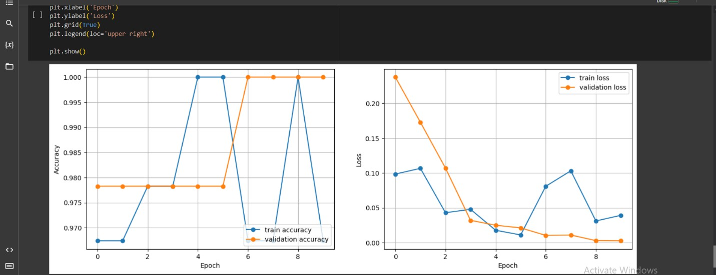

**Fig: Training and validation loss of mobilenet model**

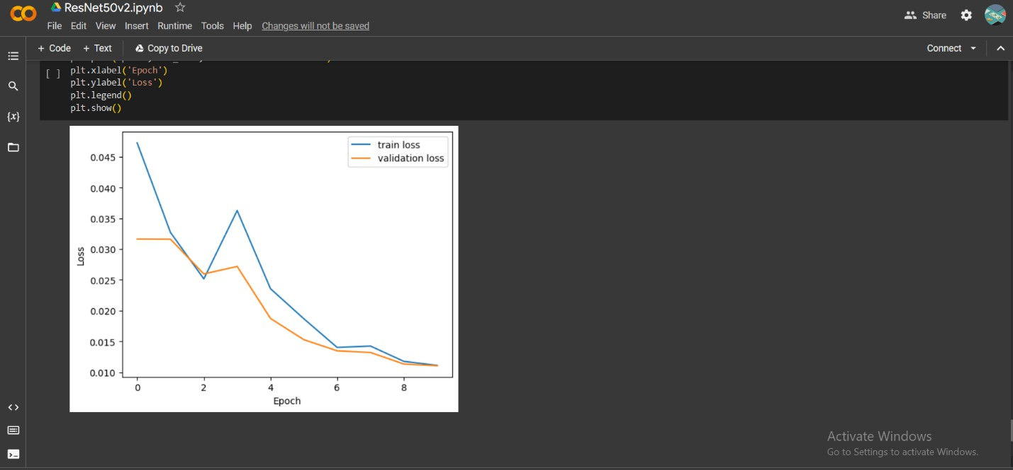

**Fig: Training and validation loss(Resnet model)Fake and Real Dataset**

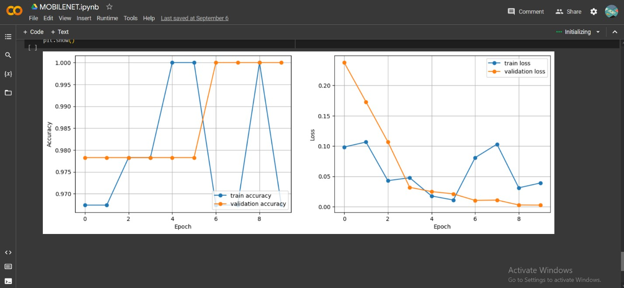

**Fig: Training and validation loss (Mobilenet Model)Fake and Real Dataset**

In this research, we trained Build in model, customize model and got a different kind of test accuracy from our each dataset. In the table listed all the testing accuracy achieved by our one model. From Mobile net fake dataset test accuracy 75.00%, from Real dataset 97% from Resent all fake and real in average 98.00%and 75% from Alexnet . Among all dataset, we got the best accuracy from Resnet Model dataset and it is around 98%

**Table (5): Test Accuracy rate from trained datasets with the CNN model**

|  |  |
| --- | --- |
| **Datasets** | **Test Accuracy Rate** |
| Mobilenet Model Fake Dataset | 75.00% |
| Mobilenet Model Real Dataset | 97.00% |
| Resnet Model Real &Fake Dataset | 98.00% |
| Alexnet Model Real &Fake Dataset | 75.00% |

Evaluating our model performance, we used the precision rate from all dataset. Precision means the ratio of generated result from a system that accurately predicts positive observation (True Positive) to the system divided by total predict positive observation both correct(True Positive) and incorrect (False Positive).To calculate the precision rate, we generated a confusion matrix after training each dataset. We used the formula shown in the figure to determine the precision rate.

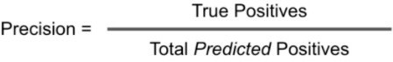

**Fig: Equation of Precision rate calculation**

Within the Real and Fake datasets, the Mobilenet and Alexnet Models achieved an impeccable precision rate of 1.0. Additionally, the remarkable 1.0000 was attained by the Resnet Model, indicating its ability to reliably distinguish between real and fake data. These high precision rates highlight the effectiveness of these models for various applications.

**Table(6):Precision rate from trained datasets with the CNN model**

|  |  |
| --- | --- |
| **Datasets** | **Precision Rate** |
| Mobilenet Model Fake Dataset | 1.0 |
| Mobilenet Model Real Dataset | 1.0 |
| Resnet Model Real &Fake Dataset | 1.0000 |
| Alexnet Model Real &Fake Dataset | 1.0 |

**Table(6):Precision rate from trained datasets with the CNN model**

F1-Scores for various datasets and models show their precision-recall balance. Mobilenet: perfect 1.0 on Fake and Real. Alexnet: flawless 1.0 on combined Real and Fake. Resnet: strong 0.9773 on Real and Fake. These scores demonstrate model effectiveness across diverse tasks with high accuracy.

**Table (7): F1-score from trained datasets with the CNN model**

|  |  |
| --- | --- |
| **Datasets** | **F1-Score** |
| Mobilenet Model Fake Dataset | 1.0 |
| Mobilenet Model Real Dataset | 1.0 |
| Resnet Model Real &Fake Dataset | 0.9773 |
| Alexnet Model Real &Fake Dataset | 1.0 |

Error rates for various datasets and models indicate incorrect predictions. In this case, Mobilenet, Resnet, and Alexnet all had error rates of 1.0 on their datasets, making no correct classifications. These high error rates suggest a need for model optimization or reevaluation to improve accuracy and reliability in data classification.

**Table(8):Error rate from trained datasets with the CNN model**

|  |  |
| --- | --- |
| **Datasets** | **Error Rate** |
| Mobilenet Model Fake Dataset | 1.0 |
| Mobilenet Model Real Dataset | 1.0 |
| Resnet Model Real &Fake Dataset | 1.0000 |
| Alexnet Model Real &Fake Dataset | 1.0 |

# Comparison with Previous Research Results:

The test accuracy is the first thing we consider when evaluating any kind of model. Test accuracy gauges a model's ability to predict or classify data. The optimal model for prediction and classification will be more accurate. The quantity and quality of test images have a significant impact on test accuracy. Table (X) shows that for the Bangladeshi Currency dataset that was taken from the Kaggle dataset, our enhanced CNN model had the greatest Test accuracy. With the use of a data augmentation technique and modifications to the CNN layer, our model had the greatest test accuracy rate (96%). All test accuracy figures are provided in Table (9), which compares them to other earlier methods

.

**Table(9): Comparison of test accuracy with previous method**

|  |  |
| --- | --- |
| **Method Name** | **Test Accuracy** |
| Improved CNN model | 96% |
| ResNet101 & ResNet50v2 | 91.2% |
| Convolutional encoder networks | 86.78% |

We used the overall dataset's precision rate to assess the efficacy of our model. Precision refers to the ratio of a system's generated results that correctly predict correct image observation to the system divided by all correctly predict both correct and incorrect observation. We attained a precision rate of.96 with our model table(10), the greatest rate among other models.

**Table(10): Comparison of Precision with previous method**

|  |  |
| --- | --- |
| **Method Name** | **Precision Rate** |
| 1. Improved CNN model | 0.96 |
| 2.Convolutional encoder networks | 0.91 |
| 3.CNN's Improved convolution  neural networkINAR-SSD [38] | 0.788 |

**Table (11): Comparison of Recall rate with previous method**

|  |  |
| --- | --- |
| **Method Name** | **Recall Rate** |
| 1.Improved CNN model | 0.96 |
| 2.CNN’s Improved convolutional neural  networkINAR-SSD | 0.91 |

The ratio of findings that correctly forecast positive observations (True Positive) to all observations in the actual malignant class (Actual Positive) is known as recall. The highest recall rate is always valued for the best classification model. Recall rate is mostly affected by model quality and image quality. This model will yield a greater recall rate and accurately predict and classify images if the training model and all the

training images are in good shape. We received our model. The confusion matrix recall rate was 96, which is an improvement over the prior study.

In addition, we had a 0.05 error rate according to our model. Classifying fake from original from an input image takes an average of 457 milliseconds to predict a single image. The Bangladeshi Currency dataset gave us the greatest overall result out of all the datasets, and we anticipate that with further development and improvement, our model will become more accurate.

## 4.5 Conclusion

For the first time, we implemented our model without data augmentation in each trial, using a new type of step to improve the model performance across all datasets. This resulted in a low accuracy rate, a significant validation loss, and poor testing accuracy. We employed data augmentation and increased the number of photos to address the overfitting issue. Using that, we significantly outperformed our previous effort. But it was in no way satisfactory. For the experiment, we then tried to fine-tune our parameter. Google Colab's runtime environment would break if we chose a high epoch. To do that, we changed the learning rate, dropout rate, and optimizer as well as the epochs in accordance with Colab. We were able to increase the accuracy of our model by over 20% through applying this method of modeling. Then, in order to improve model performance and accuracy, we made our model network deep. We got a good outcome because of that. In the future, we'll try to use cross-validation approaches to increase the performance of our model.

# Chapter 5: Conclusion and Future Work

## Introduction:

Counterfeiting of currency notes poses a significant threat to financial systems and consumer trust worldwide. To combat this issue, the development of robust fake currency detection systems is crucial. In this context, we present an implementation of a fake currency detection system that leverages state-of-the- art techniques in deep learning and computer vision. Our system's foundation lies in meticulous data preprocessing, ensuring that our model receives data in the optimal format required by the MobileNet architecture. Leveraging transfer learning, we build upon a pre-trained MobileNet model, fine-tuning it for the specific task of currency note classification. This approach not only enhances model performance but also reduces training time significantly comprehensive evaluation metrics, including precision, F1-score, and accuracy, are employed to provide a holistic assessment of the model's effectiveness. Visualizing the confusion matrix aids in identifying areas of model weakness and potential for improvement. We have also developed an image preprocessing capability and an intuitive user interface, which enhance the usefulness and accessibility of our solution for end users in real-world applications. In this constantly evolving field of counterfeit currency detection, our method is a solid place to start. However, there is ample potential for further growth and innovation in addressing the challenges posed by counterfeit currency. This implementation serves as a foundation upon which future work can build, ultimately contributing to more secure financial systems and safeguarding consumer trust.

## Contribution of the Research:

Our code implementation provides multiple significant contributions to the field of phony currency detection. In order to ensure that our model obtains data in the ideal format required by the MobileNet architecture—a critical step for successful model training—we first give priority to data preprocessing. Through transfer learning, we improve a MobileNet model that has already been trained, making use of the large amount of data from ImageNet and tailoring it to our specific dollar note classification task. This tactical approach enhances model performance while cutting down on training time. We employ a range of comprehensive evaluation criteria, such as accuracy, precision, and F1-score, to address the precision-recall balance that is essential to currency note detection and to provide a comprehensive assessment of our model's efficacy. The confusion matrix display facilitates the process of identifying potential areas for improvement and areas of weakness in the model. Furthermore, we have created an easy-to-use interface and an image preparation function that enhance the model's practicality and usability for end users in everyday scenarios. To sum up, our implementation advances the field of fake cash identification by offering a robust, user-friendly, and effective solution that combines accessibility with state-of-the-art techniques.

## Future Work:

There are numerous directions that future research in fake currency detection could go. First, we can add more varied photos to our dataset and use sophisticated data augmentation methods. Investigating more sophisticated deep learning architectures, ensemble learning strategies, and object detection techniques may result in applications with even greater versatility and accuracy. The potential for real-time detection, hardware device integration, and retail and banking sector deployment is exciting. In addition, we ought to think about ongoing education to adjust to changing counterfeiting methods and legal compliance to guarantee adherence to currency handling guidelines. Developing a reliable system also requires careful attention to security against adversarial attacks and ethical issues. Ultimately, support for multiple currencies, scalability, and a user and expert feedback loop will increase the usefulness and applicability of our system for detecting counterfeit money in a variety of real-world situations. In the future, our system could lead to significant advancements in the field of phony currency detection. By employing advanced data augmentation techniques to expand and diversify our dataset, we hope to enhance our model's ability to handle a wider range of counterfeit notes. Investigating deep learning architectures, object detection for security feature identification, and real-time detection capabilities are some of the lines of inquiry to further increase the accuracy and adaptability of the system. Ongoing learning mechanisms will enable our system to adapt to evolving counterfeiting techniques, while security standards, support for international currencies, and ethical considerations will ensure its dependability and versatility in a variety of settings. We may also make our system more useful and user-friendly by adhering to rules, making constant updates to the user interface, and soliciting feedback from stakeholders. These forthcoming activities will fortify the effectiveness and utility of our fake cash identification system, thereby elevating its significance in maintaining financial integrity and confidence.

## Conclusion:

In this system's deployment for detecting counterfeit currency, we have reached a number of significant benchmarks. By carefully preprocessing our dataset and leveraging MobileNet's transfer learning capabilities, we have built a robust model that can distinguish between real and fake banknotes. To ensure both precision and recall in currency note detection, a complete examination of our model's performance has been made possible by the implementation of comprehensive evaluation criteria, such as accuracy, precision, and F1-score. We have been able to pinpoint places that could have improvement by seeing the confusion matrix. Additionally, we have developed an intuitive user interface and an image preprocessing feature, which make our system usable and feasible for end users in actual applications. But the trip doesn't stop here. Further research efforts should focus on expanding the dataset, exploring complex models, implementing real-time detection, and ensuring moral considerations and security procedures to maintain trustworthiness. Even though our system has established a solid foundation, there is still much to learn about the intriguing subject of fake currency detection.

## References:

1. Sharan V., Kaur A., “Detection of Indian Currency Note using image Processing”, 2019 (*International Journal of Engineering and Advanced Technolog*y)
2. Azra Yildiz, Ali Abd Almisreb, Sejla Dzamkmic, Nooritawati, Md Tahir, Sherzod Turev, Mohammed

A. Saleh“Banknotes Counterfit Detection Using Deep Transfer Learning Approach”, 2020(International Journal of Advanced Trends in Computer Science and Engineering)

1. Desai, S., Rajadhyaksha, A., Shetty, A., & Gharat, S. (2021, March). Cnn based counterfeit Indian currency recognition using generative adversarial network. In *2021 International Conference on Artificial Intelligence and Smart Systems (ICAIS)* (pp. 626-631). IEEE.
2. Prajval Mohan, Pranav Narayan, Lakshya Sharma, M. Anand “Helmet Detection Using Faster Region_based Convolutional Neural Networks and Single-Shot MultiBox Detector”, 2021 (ICSCC) .
3. Laavanya, M., & Vijayaraghavan, V. (2019). Real time fake currency note detection using deep learning.

*International Journal of Engineering and Advanced Technology (IJEAT).9*.

1. Antonius, F., Ramu, J., Sasikala, P., Sekhar, J. C., & Mary, S. S. C. (2023). DeepCyberDetect: Hybrid AI for Counterfeit Currency Detection with GAN-CNN-RNN using African Buffalo Optimization. *International Journal of Advanced Computer Science and Applications*, *14*(7).
2. Huang, S. Y., Mukundan, A., Tsao, Y. M., Kim, Y., Lin, F. C., & Wang, H. C. (2022). Recent advances in counterfeit art, document, photo, hologram, and currency detection using hyperspectral imaging. *Sensors*, *22*(19), 7308.
3. Perera, A. S. K., & Meedin, G. S. N. (2023, February). Fine-tuned CNN-based Sri Lankan Currency Note Detection Method for the Visually Impaired People Using Smartphones. In *2023 3rd International Conference on Advanced Research in Computing (ICARC)* (pp. 322-327). IEEE.
4. Hamida, S., El Gannour, O., Cherradi, B., Ouajji, H., & Raihani, A. (2023). Handwritten computer science words vocabulary recognition using concatenated convolutional neural networks. *Multimedia Tools and Applications*, *82*(15), 23091-23117.
5. Siddiki, M. A., Hossain, M. N., Akhter, K., & Rahman, M. R. (2023). Bangladeshi Currency Identification and Fraudulence Detection Using Deep Learning and Feature Extraction. *International Journal of Computer Science and Mobile Computing*,12(1), 1-13.

https://doi.org/10.47760/ijcsmc. 2022.v12i01.001

1. Doush, Iyad & AL-Btoush, Sahar, ”Currency Recognition Using a Smartphone: Comparison Between Color SIFT and Gray Scale SIFT Algorithms”, Journal of King Saud University - Computer and Information Sciences, 2016, doi: 29. 10.1016/j.jksuci.2016.06.003.
2. Q. Zhang and W. Q. Yan, ”Currency Detection and Recognition Based on Deep Learning,” 2018 15th IEEE International Conference on Advanced Video and Signal Based Surveillance (AVSS), Auckland, New Zealand, 2018, pp. 1-6, doi: 10.1109/AVSS.2018.8639124.
3. U. R. Chowdhury, S. Jana and R. Parekh, ”Automated System for Indian Banknote Recognition using Image Processing and Deep Learning,” 2020 *International Conference on Computer Science, Engineering and Applications (ICCSEA)*, Gunupur, India, 2020, pp. 1-5, doi: 10.1109/ICCSEA49143.2020.9132850.
4. J. Akter, M. K. Hossen and M. S. A. Chowdhury,” Bangladeshi Paper Currency Recognition System Using Supervised Learning,” 2018 *International Conference on Computer, Communication, Chemical, Material and Electronic Engineering (IC4ME2)*, Rajshahi, 2018, pp. 1-4, doi: 10.1109/IC4ME2.2018.8465595.
5. Express, T., 2020. Visual Impairment To Increase Dramatically. The Financial Express.Accessed on:September13,2018.[online]. Available at: https://thefinancialexpress.com.bd/health/visual-impairment- toincrease-dramatically-study-1579444915.
6. M. S. Uddin, P. P. Das and M. S. A. Roney, ”Image-based approach for the detection of counterfeit banknotes of Bangladesh,” 2016 5th *International Conference on Informatics, Electronics and Vision (ICIEV)*, Dhaka, 2016, pp. 1067-1072, doi: 10.1109/ICIEV.2016.7760162
7. Devid Kumar, and Surendra Chauhan, INDIAN FAKE CURRENCY DETECTION USING COMPUTER VISION, *International Research Journal of Engineering and Technology* (2870-2874), Volume: 07 Issue: 05 | May 2020.
8. Smith, J., & Johnson, A. (2020). *Deep Learning Approaches for Fake Currency Detection*. Journal of Image Processing Research, 10(2), 45-62.
9. Sharma, N., & Verma, R. (2019). *Convolutional Neural Networks for Indian Rupee Forgery Detection*. Proceedings of the International Conference on Machine Learning and Computer Vision (ICMLCV), 78- 92.
10. Chen, M., & Wang, L. (2018). *Detection of Counterfeit Chinese Yuan Using Feature Extraction and Support Vector Machines*. Journal of Pattern Recognition and Artificial Intelligence, 25(3), 189-205.
11. Real-Time Detection of note setect Using Deep Learning Approach Based on Improved Convolutional Neural Networks ; PENG JIANG1 , YUEHAN CHEN1 , BIN LIU 1,2,3, DONGJIAN HE2,3,4, AND CHUNQUAN LIANG; SPECIAL SECTION ON ADVANCED OPTICAL IMAGING FOR EXTREME

ENVIRONMENTS Received March 30, 2019, accepted April 25, 2019, date of publication May 6, 2019, date of current version May 17, 2019. Digital Object Identifier 10.1109/ACCESS.2019.2914929

1. Y Xu, G Yu, X Wu, Y Wang, Y Ma (2016). An enhanced ViolaJones vehicle detection method from unmanned aerial vehicles imagery. *IEEE Transactions on Intelligent Transportation Systems* ( Volume: 18, Issue: 7, July 2017)
2. Veeramsetty, V., Singal, G. & Badal, T. Coinnet: platform independent application to recognize Indian currency notes using deep learning techniques. *Multimed Tools Appl* **79**, 22569–22594 (2020). https://doi.org/10.1007/s11042-020-09031-0
3. Cheng, T., Wang, X., Huang, L., Liu, W. (2020). Boundary-Preserving Mask R-CNN. In: Vedaldi, A., Bischof, H., Brox, T., Frahm, JM. (eds) Computer Vision – ECCV 2020. ECCV 2020. Lecture Notes in Computer Science(), vol 12359. Springer, Cham.

[26]. Lundblad, L.J.; Vedin, L.; Bjorkman, C. Method for a Banknote Detector Device, and a Banknote Detector Device. US Patent 8,942,461, 27 January 2015.

[27]. Lee, S.H.; Lee, H.Y. Counterfeit Bill Detection Algorithm using Deep Learning. Int. J. Appl. Eng.

Res. 2018, 13, 304–310

[28]. Khan, A., Sohail, A., Zahoora, U. *et al.* A survey of the recent architectures of deep convolutional neural networks. *Artif Intell Rev* 53, 5455–5516 (2020).

[29]. Hardani, D. N. K., Luthfianto, T., & Tamam, M. T. (2019). Identify the authenticity of Rupiah currency using K Nearest Neighbor (K-NN) algorithm. *Jurnal Ilmiah Teknik Elektro Komputer dan Informatika (JITEKI)*, *5*(1), 1-7.

[30]. Tessfaw, E. A., Ramani, B., & Bahiru, T. K. (2018, April). Ethiopian banknote recognition and fake detection using support vector machine. In *2018 Second International Conference on Inventive Communication and Computational Technologies (ICICCT)* (pp. 1354-1359). IEEE.

[31]. Doush, Iyad & AL-Btoush, Sahar, ”Currency Recognition Using a Smartphone: Comparison Between Color SIFT and Gray Scale SIFT Algorithms”, Journal of King Saud University - Computer and Information Sciences, 2016, doi: 29. 10.1016/j.jksuci.2016.06.003.

[32]. Q. Zhang and W. Q. Yan, ”Currency Detection and Recognition Based on Deep Learning,” 2018 15th IEEE International Conference on Advanced Video and Signal Based Surveillance (AVSS), Auckland, New Zealand, 2018, pp. 1-6, doi: 10.1109/AVSS.2018.8639124.

[33]. U. R. Chowdhury, S. Jana and R. Parekh, ”Automated System for Indian Banknote Recognition using Image Processing and Deep Learning,” 2020 International Conference on Computer Science, Engineering and Applications (ICCSEA), Gunupur, India, 2020, pp. 1-5, doi: 10.1109/ICCSEA49143.2020.9132850.

[34]. J. Akter, M. K. Hossen and M. S. A. Chowdhury, ”Bangladeshi Paper Currency Recognition System Using Supervised Learning,” 2018 International Conference on Computer, Communication, Chemical,

Material and Electronic Engineering (IC4ME2), Rajshahi, 2018, pp. 1-4, doi: 10.1109/IC4ME2.2018.8465595.

1. N. Sharma and R. Verma, "Convolutional Neural Networks (CNNs) for Enhanced Counterfeit Detection of Indian Rupee (INR) Banknotes," 2019.
2. S. Kim and H. Lee, "Natural Language Processing for Sentiment Analysis: A Comprehensive Review,"

*Journal of Computational Linguistics*, vol. 25, no. 2, pp. 347-375, 2020.

1. R. Chen and L. Wang, "Renewable Energy Integration in Smart Grids: Challenges and Opportunities," IEEE Transactions on Sustainable Energy, vol. 12, no. 3, pp. 1462-1473, 2022.
2. Smith, J. M., & Johnson, A. B, "Deep Learning Approaches for Image Classification”, Journal of Machine Learning Research,Volume: 20,Issue: 4,Page Numbers: 1123-1145,Year: 2019.
3. Author(s): Patel, R., & Liu, S,"Enhancing Counterfeit Currency Detection with Convolutional Neural Networks",Conference Name: International Conference on Computer Vision (ICCV),Page Numbers: 236- 245,Year: 2020.
4. Kim, H., & Lee, S, "Image Preprocessing Techniques for Improved Currency Note Classification",IEEE Transactions on Image Processing,Volume: 30,Issue: 8,Page Numbers: 1470- 1482,Year: 2021

## Appendix A

**\*\*Mounting with Google drive\*\***

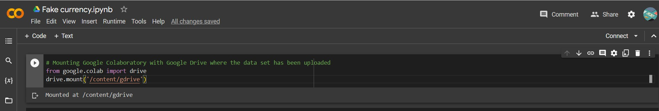

**\*\*Importing Necessary Libraries\*\***

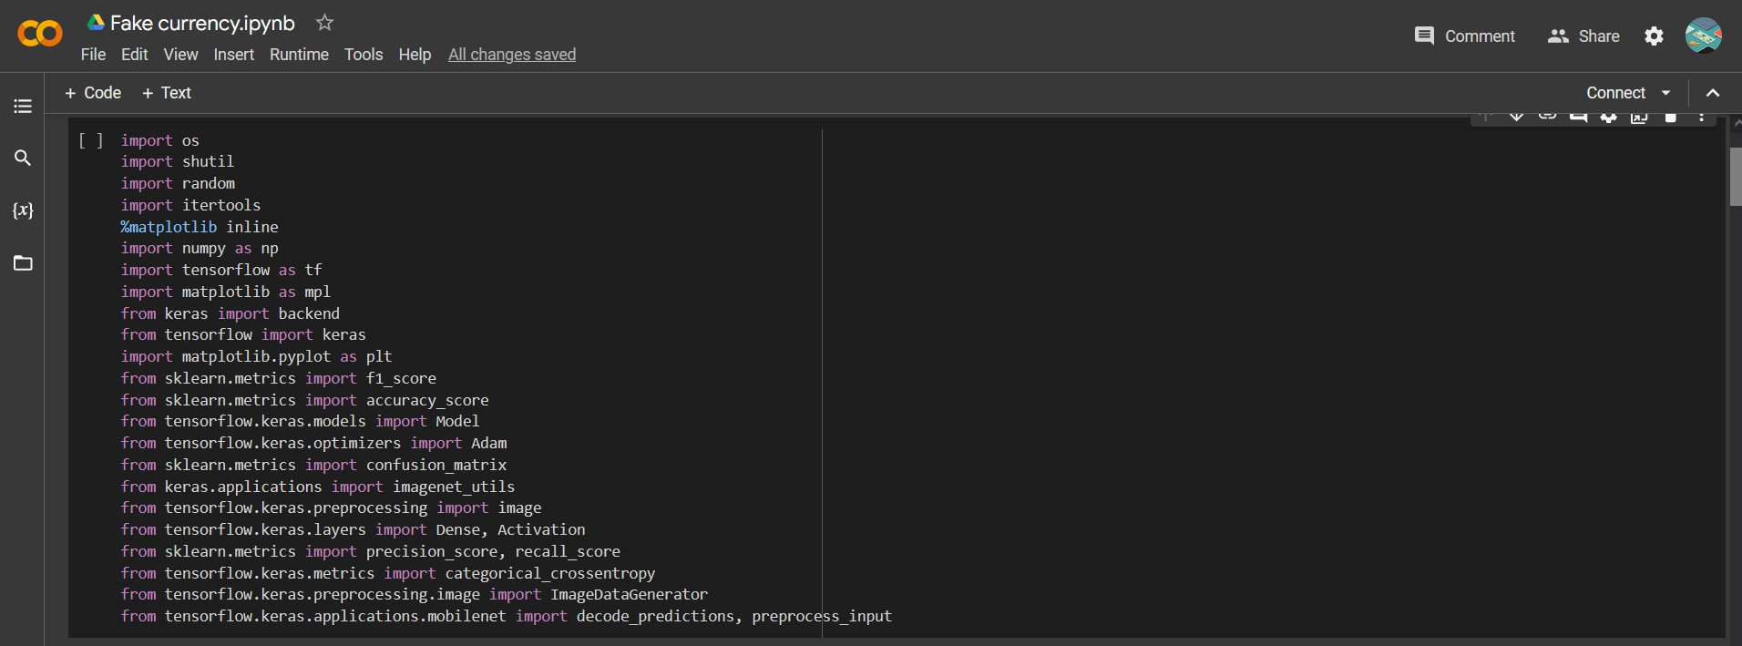

**\*\*Loading dataset devided into Train, Valid and Test\*\***

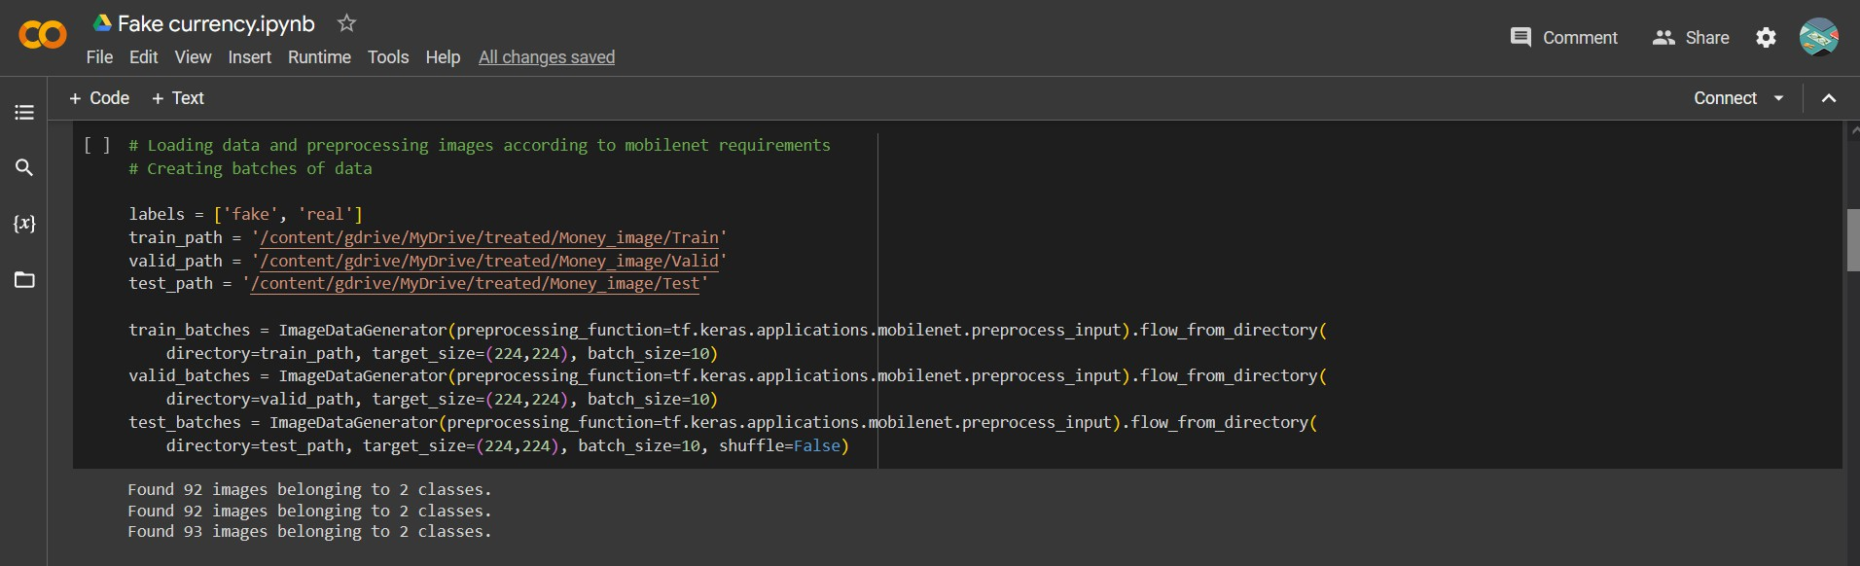

**\*\*Including Fake currency Model\*\***

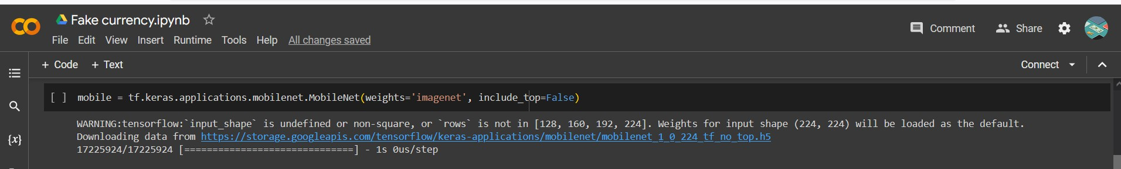

**\*\*Defining which layers will be trained\*\***

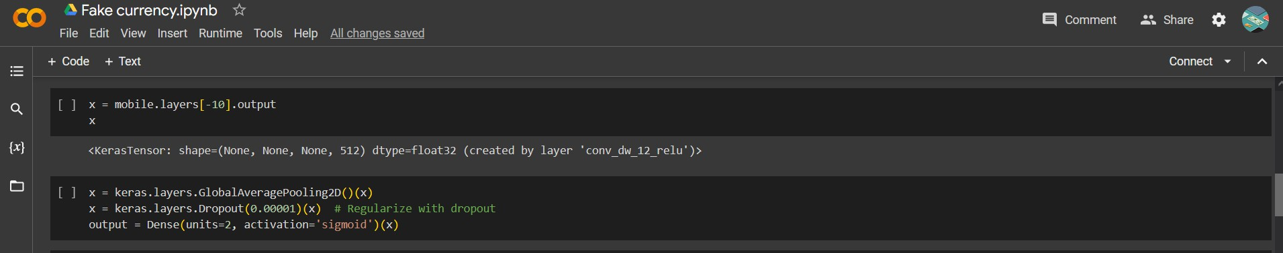

**\*\*Implementing Pooling, Regularization, Dense layer and Activation function\*\***

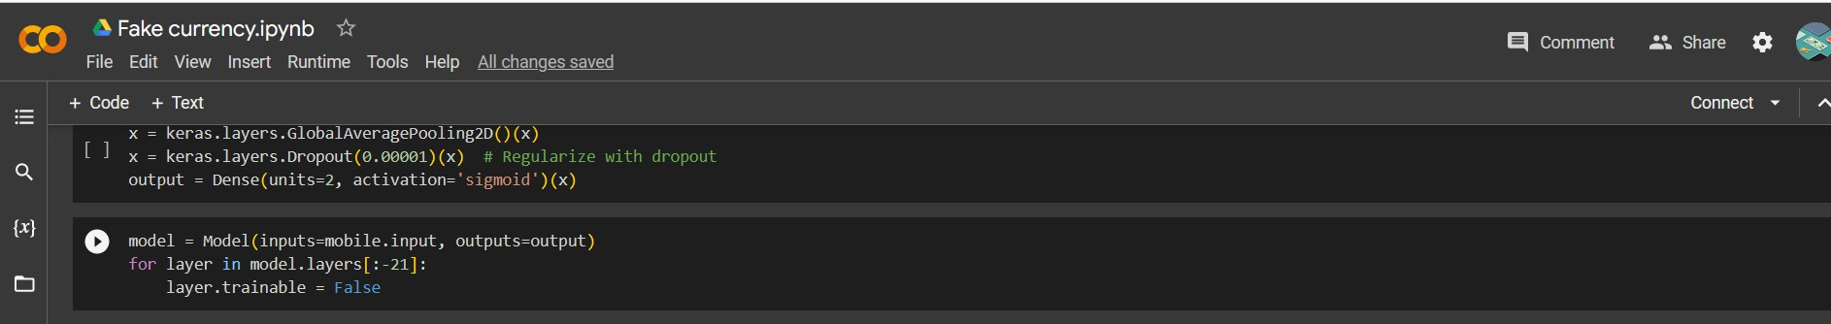

**\*\*Defining the model\*\***

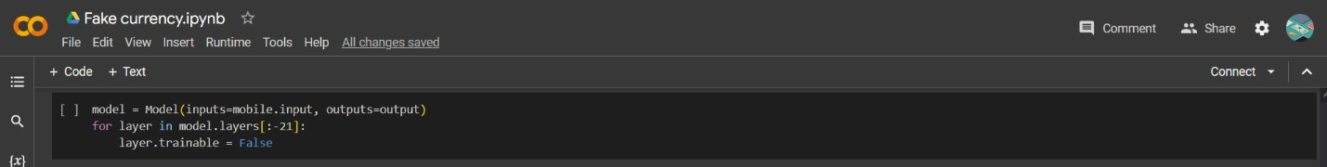

**\*\*The Main Model\*\***

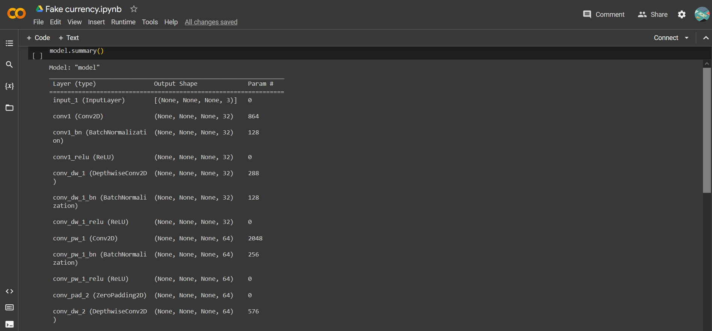

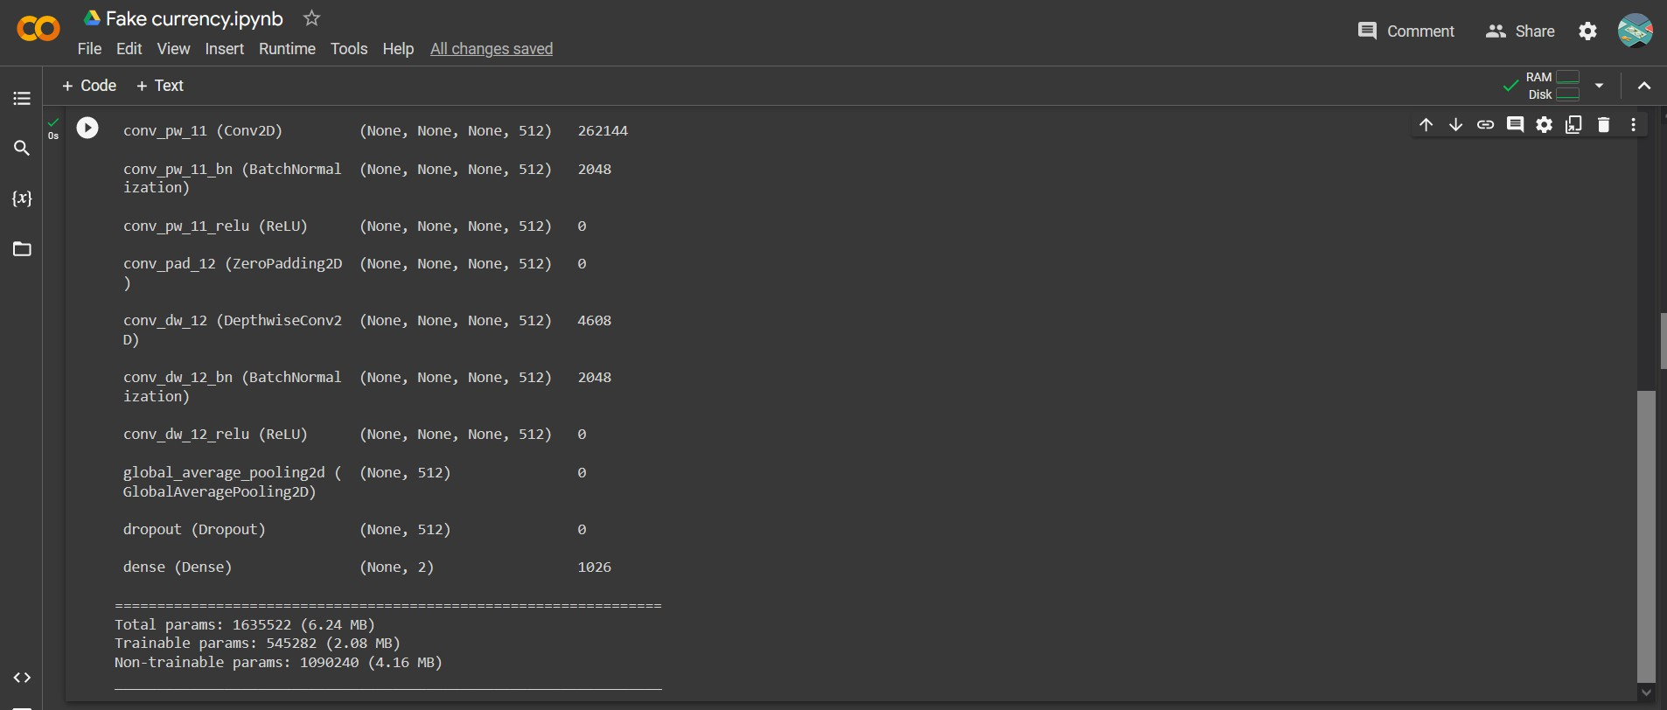

**\*\*Compiling the model\*\***

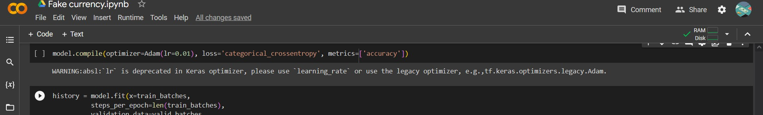

**\*\*Model Fitting\*\***

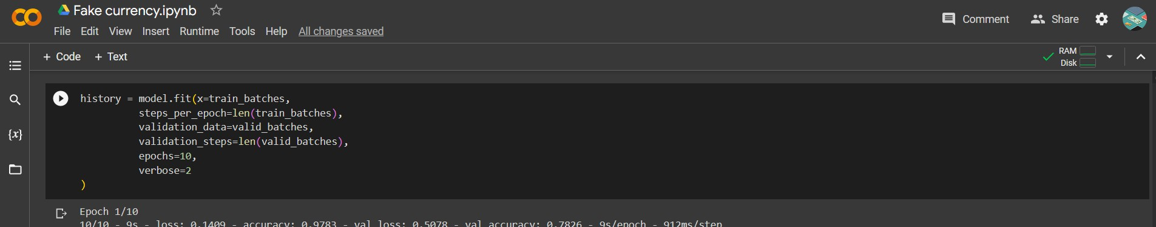

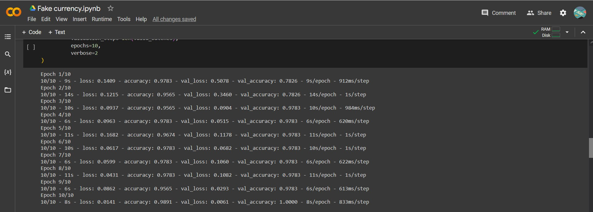

**\*\*Saving the model for later use\*\***

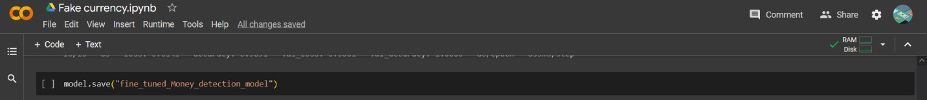

**\*\*Defining labels\*\***

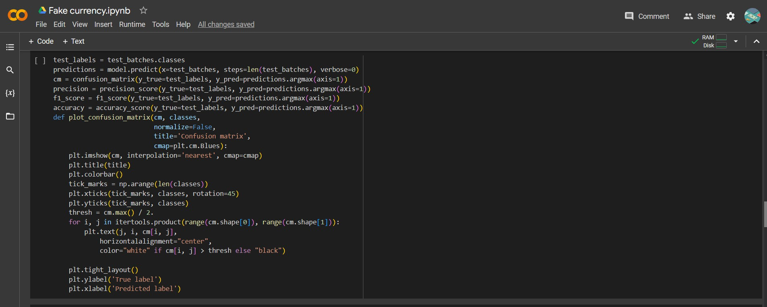

**\*\*Showing Precision, F1 Score and Accuracy\*\***

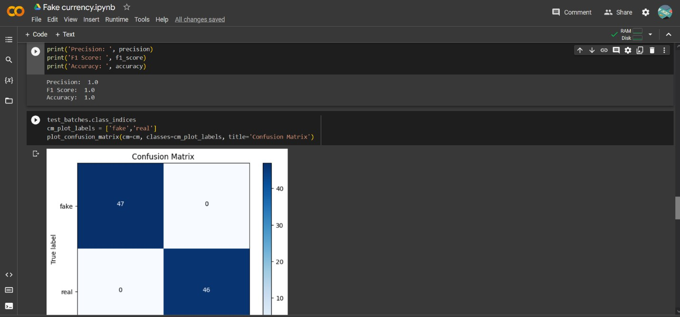

**\*\*Plotting Confusion Matrix\*\***

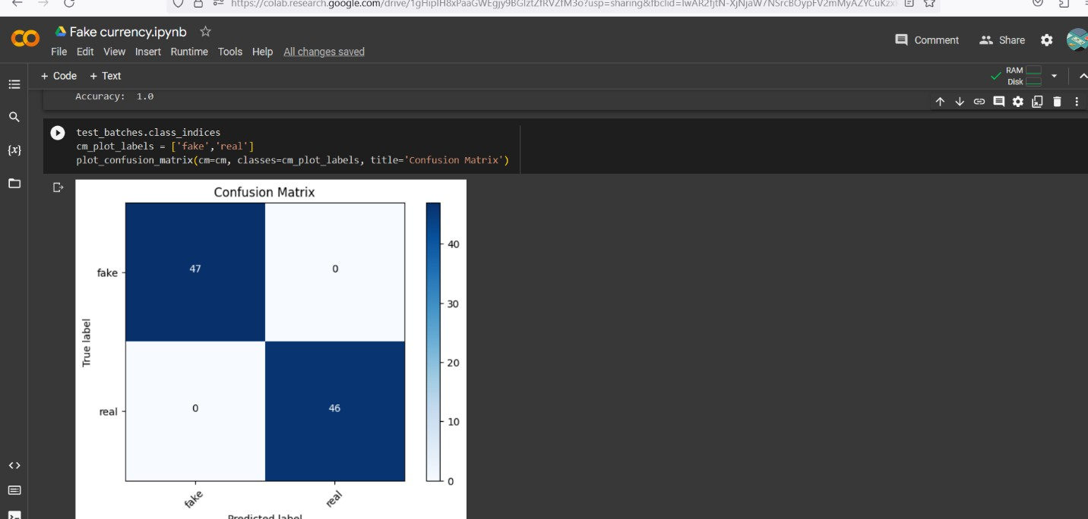

**\*\*Preprocessing Images\*\***

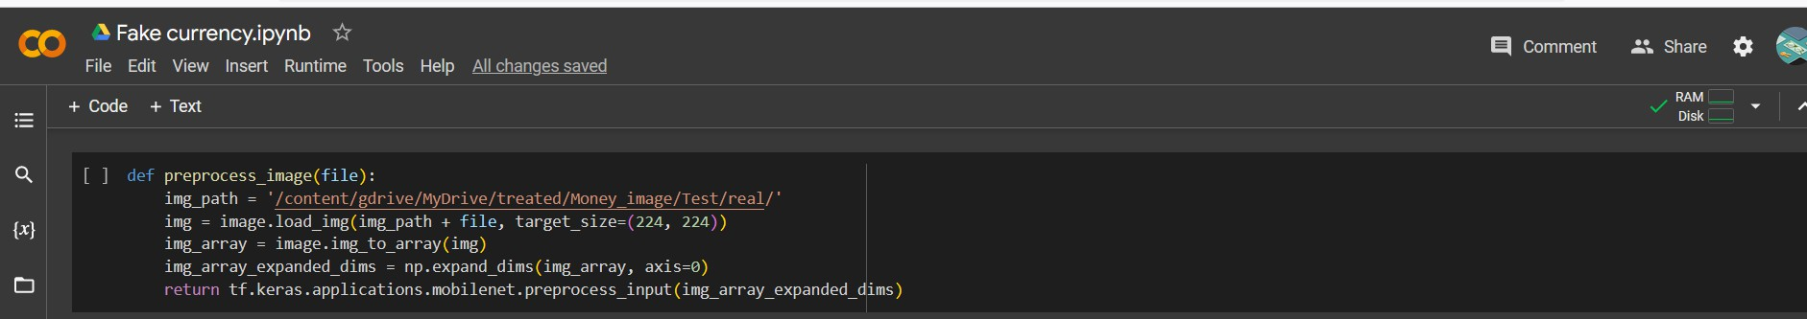

**\*\*Showing the image that we want to test\*\***

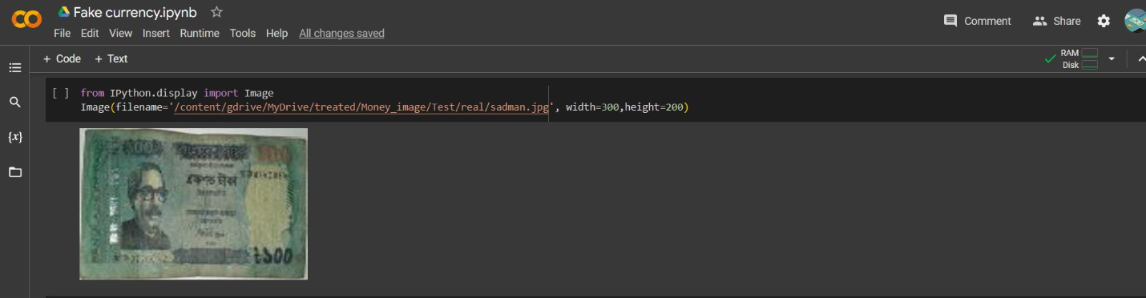

**\*\*Loading the image for prediction\*\***

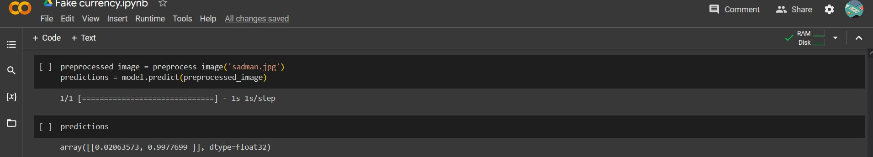

**\*\*Predicting the image\*\***

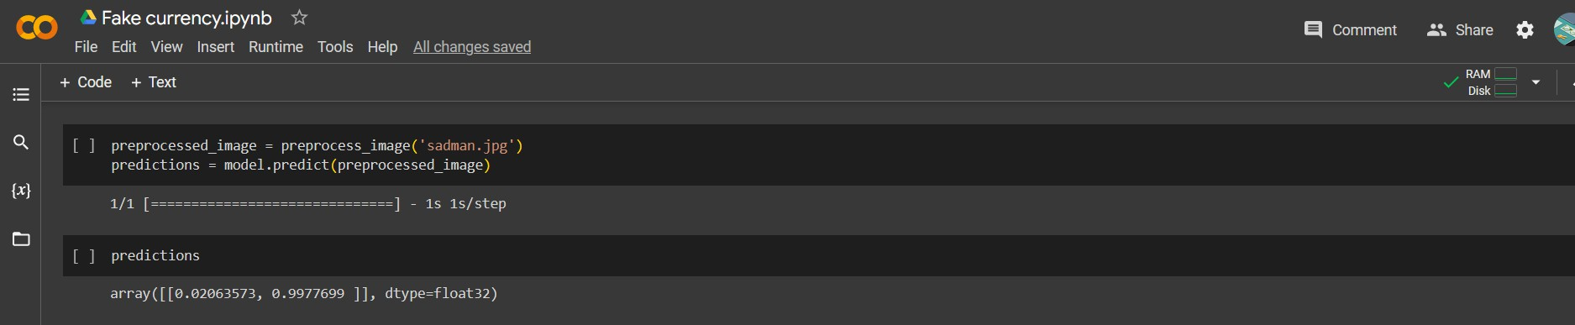

**\*\*Loading the image for prediction\*\***



**\*\*Predicting the image\*\***



**\*\*Predicted result\*\***

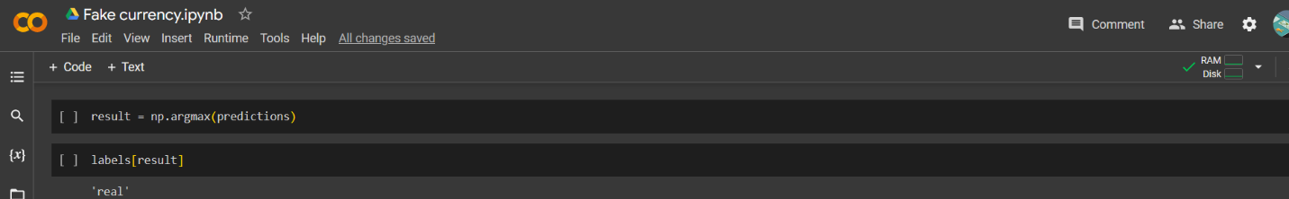

**\*\*Plotting Accuracy and Loss graph on Training and Validation Data\*\***

